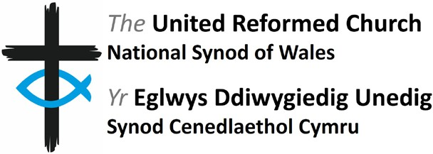

Personal Assistant & Administration Manager
Job Description

Purpose of the role:
- to support The Wales Synod Moderator as they carry out their role
- to provide administration to the Synod Support Team
- to ensure that accurate records are kept and relevant reports are completed
- to be the primary organiser of Synod Meetings and other events.

Specific responsibilities
PA to the Wales Synod Moderator
- First point of contact for Moderator enquiries; responding confidentially to phone calls, emails and letters in a reasonable period and forwarding as appropriate
- Diary management for Moderator
- Plan visits for the Moderator to individuals, churches and meetings; to include travel, accommodation and any additional venues required
- Carry out research, filing (hardcopy and electronically) and information retrieval
- Maintain accurate records, including database, paper & digital filing and email lists
- Prepare reports on Ministerial changes and the monthly Ministerial vacancy list
- Managing Ministers’ personnel files, fit notes and other forms
- Provide administrative support as needed

Administration

To provide administrative support the Synod Support Team
- Work in partnership with colleagues to keep calendars up to date
- Liaise with colleagues to plan meetings, services and events. Book venues, travel and accommodation, along with any supplementary requirements as necessary. Act as on-site organiser during the events
- Maintain accurate information on the database and communicate changes to the Synod Support Team
- Overseeing and implementing the Annual Church and Safeguarding Returns
- To produce and distribute the Synod Yearbook
- Ensure that electronic and hardcopy records are held in keeping with GDPR
- To work with the Synod Clerk in preparation of communications material
- Minute meetings when required
- Manage the supply of stationery and office consumables

General

- Be part of the Synod Support Team and attend events and training as required
- Take on other ad hoc tasks when required.

Scope
Salary £33,416.80, 0.8 FTE (FTE 1.0 equivalent £41,711)
Hours: Part Time (28 hours per week, with a minimum of 3 days in the office)
Contract: Permanent (subject to a three-month probationary period)
Leave entitlement: 20 days pa, plus statutory holidays
Pension scheme available.

Location: Synod Office, Minster Road, Cardiff, CF23 5AS. Standard office hours are
9.30am to 5pm including a 30 minute (unpaid) lunch break.
Some weekend or evening work will be required, as will travel to meetings.

Due to the nature of the role, flexi-time may be accrued or depleted outside normal
parameters to facilitate more flexibility, by agreement.

