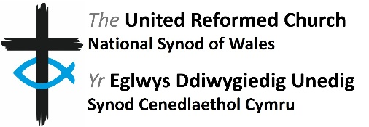
Role Description for
Member of Mission and Discipleship Board

Role Description

Role Title | Member of Mission and Discipleship Board
Governance Area | Mission and Discipleship
Main Points of Contact | Convenor of Mission and Discipleship
Connected Roles | Synod Advocates receive oversight and support from this Board.
Sources of Support | Secretary to the committee is the Administration Officer
Location | The majority of meetings will be online. Where meetings are in person, these are likely to take place at  the Synod Office, Cardiff.
Time Commitment | Three online and one in person meetings per annum (dates and times suitable for the membership of committee) plus additional follow-up work between meetings. Meetings usually take place on a Tuesday afternoon.
Remuneration | Volunteers are not remunerated. The URC will ensure financial expenses incurred by volunteers while supporting the work of the Member of Mission and Discipleship Board will be reimbursed, in accordance with the URC expenses policy.
Background: The synod’s Mission and Discipleship Board looks after all areas of the Synod’s work related to Mission and/or Discipleship.
Committee Summary:
Mission and Discipleship Board is responsible for:
- Implementation of Synod priorities
- Development and encouragement of mission and discipleship
- Oversight of church and society issues and encouraging engagement
- Oversight of global links and partnerships
- Oversight of intergenerational work
- Oversight and support of Synod Advocates
- Written report to each Synod Meeting

Principal responsibilities and duties

Attending and participation in meetings
  - Attend as many of the Committee’s meetings as practicably possible.
  - Read all papers carefully in advance of each meeting in order to participate in discussions and ask appropriate questions.
  - Be willing to support particular pieces of committee work outside of the meetings from time to time.

Training
Undertake training in key areas as highlighted within the induction and through ongoing conversation with the Convenor and Secretary.

Expected Standards
This section refers to the way in which the role should be done as opposed to the duties/ responsibilities themselves.

- Promote a culture of open and effective communication.
- Actively foster an environment which nurtures equality and cherishes diversity.
- Take responsibility for own personal development and develop skills and knowledge applicable to this role.
- Ensure compliance with safeguarding practice.

This role description reflects the overall scope and responsibilities of the role. However, it may change and evolve over time in order to meet organisational needs and this role description will therefore be subject to periodic review and change if required.

