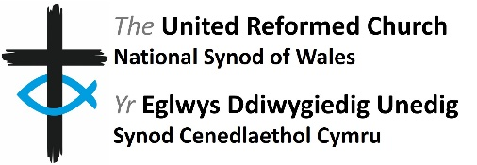
Person Specification

Role: Member of Mission and Discipleship Board

Requirements | Essential | Desirable
Experience and Knowledge | - A good understanding of what is meant by “mission” and “discipleship” in a URC context  - Experience of engaging in either work in a local church context | - Experience of holding a leadership role in a local church  - An understanding of the synod’s work and mission priorities
Skills and Abilities | - Work collaboratively with a diverse range of people  - Good IT skills including Microsoft Office, Zoom and email | - Creative thinking and problem solving
Other |  | - Member of the United Reformed Church

