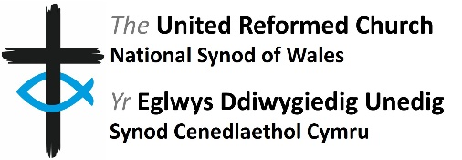
Role Description for
Member of Finance and Property Board

Role Description

Role Title | Member of Finance and Property Board
Governance Area | Finance and Property
Main Points of Contact | Treasurer  Property Officer
Connected Roles | n/a
Sources of Support | Secretary to the committee is the Synod Property Officer.
Location | The majority of meetings are hybrid, meeting at the Synod Office and on Zoom. One meeting per year is an in person meeting at a local church, moving around the synod. The AGM is held online.
Time Commitment | Four full meetings and one Annual General Meeting per annum plus additional follow-up work between meetings. Full meetings generally take place on a Wednesday from mid-morning to mid-afternoon with lunch provided for those attending in person. The AGM is a shorter meeting which takes place on Zoom at a time convenient to all attendees.
Remuneration | Volunteers are not remunerated. The URC will ensure financial expenses incurred by volunteers while supporting the work of the Finance and Property Board will be reimbursed, in accordance with the URC expenses policy.
Background: The Finance and Property Board is one of the main committees of the synod. It meets jointly with the URC (Wales) Trust Executive Council, as FPB & Trust.
Committee Summary:
Finance and Property Board is responsible for:
- Implementation of Synod priorities
- Formulation of policies for consideration by Synod Meeting
- Property matters (approval, oversight, support and guidance)
- Manse policy (oversight and guidance)
- Ministry and Mission Fund contributions (direction, development and advocacy)
- Mission Development Fund grants (approval and monitoring)
- Financial matters (oversight, support and guidance) and reporting accounts to Synod Meeting
- Formulating budgets for approval by Synod Meeting
- Indicate need for a District Council meeting where required
- Close working with URC (Wales) Trust Company Limited
- Written report to each Synod Meeting

Principal responsibilities and duties

Attending and participation in meetings
  - Attend as many of the Committee’s meetings as practicably possible.
  - Read all papers carefully in advance of each meeting in order to participate in discussions and ask appropriate questions.
  - Familiarise yourself with the Committee’s Terms of Reference (and delegated authority from Synod Meeting).
  - Be willing to support particular pieces of committee work outside of the meetings from time to time.

Training
Undertake training in key areas as highlighted within the induction and through ongoing conversation with the Convenor and Secretary.

Expected Standards
This section refers to the way in which the role should be done as opposed to the duties/ responsibilities themselves.

- Promote a culture of open and effective communication.
- Actively foster an environment which nurtures equality and cherishes diversity.
- Take responsibility for own personal development and develop skills and knowledge applicable to this role.
- Ensure compliance with safeguarding practice.

This role description reflects the overall scope and responsibilities of the role. However, it may change and evolve over time in order to meet organisational needs and this role description will therefore be subject to periodic review and change if required.

