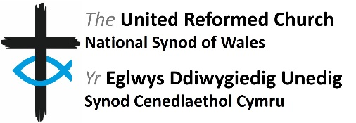
Person Specification

Role: Member of Finance and Property Board

Requirements | Essential | Desirable
Experience and Knowledge | - Knowledge and/or experience of organisational finance and/or matters related to property ownership and maintenance | - Knowledge of synod operations and governance structures or a willingness to learn
Skills and Abilities | - Work collaboratively with a diverse range of people  - Good IT skills including Microsoft Office, Zoom and email
Other | - Member of the United Reformed Church

