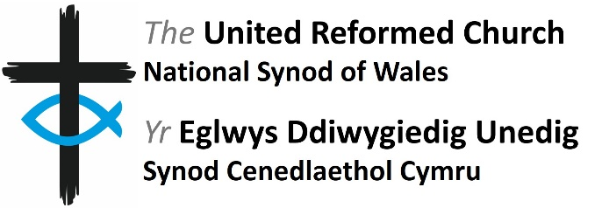
Safeguarding Training
Booking Form

Please complete this form and return it to Judy Harris by email at safeguarding.urcwales@urc.org.uk or by post to the Synod Office (Minster Road, Cardiff, CF23 5AS).
Name
Role
Address
Email Address
Telephone
Your Church
Training Level
Training Date
Training Venue

Please indicate if you have any accessibility needs:

Please tick to confirm that you are over 18 .
By signing this form you are confirming that you consent to the National Synod of Wales holding and processing your personal data for the following purposes (please tick the boxes to indicate where you grant consent):
I consent to the Synod contacting me by post email telephone .
I consent to the Synod informing me about news and events that are relevant to safeguarding .
I consent to the Synod sharing my email address with other safeguarding training attendees (e.g. for the purposes of arranging travel) .
Signature |  | Date

You can grant consent to all the purposes, one of the purposes, or none of the purposes stated above. Where you do not grant consent we will not be able to use your personal data (for example, we will not be able to let you know about forthcoming events) except in certain limited situations, such as where we are required to do so by law or to protect members of the public from serious harm. You can find out more about how we use your data at https://www.urcwales.
org.uk/wp-content/uploads/2019/01/data-privacy-statement.pdf . You can withdraw or change your consent at any time by contacting the Synod Clerk at the Synod Office (Minster Road, Cardiff, CF23 5AS) or synodclerk@urcwales.org.uk . Please note that all processing of your personal data will cease once you have withdrawn consent, other than where this is required by law, but this will not affect any personal data that has already been processed prior to this point.

